Project Report

## Parallel and Distributed Computing

Group members:

* Syed Hamza Ali(59035)
* Arqum Usmani(59252)
* Jawwad Uddin Khan(59499)
* Usman Tariq(59148)

Submitted to: Dr. Ayaz Khan

**Table of contents:**

|  |  |
| --- | --- |
| S.no. | Contents |
| i. | Introduction |
| ii. | Goals |
| iii. | Achievements |
| iv. | Individual Contribution |

**Introduction:**

Our project is based on a media control server who is responsible for uploading advertisement videos on the SQL Server Management. We use Sql Server Management as our database in which we stores advertisements and we also defined clients (in our case screens) in which these videos will play with the staring time of the video, date to play the video and the duration to play the video.

**Goals:**

Our project make it easy for advertisement companies to manage screens placed in different parts of the city from a single Media Control Server.

**Acheivements:**

**Requirements Gathering:**

In this phase we gather requirements marketing experts that what features should be in this project which make it reliable for the market. These features are:

1. Communication between server and client must be reliable.
2. Server must be able to upload and delete videos from the database server.
3. Server must specify screens, date, time and duration of the videos.
4. GUI of the client side must be interactive.

**Analysis:**

Analysis phase was all about the exploration of user interface according to the tools we will use that how server contains media list on server end will shown up at both server end and client end, its items in categories of media files such as audio, video and images & the subcategories of audio files, video files and image files. How the upload and open file options shown on client-end will perform (the backend logic) and how the communication between the client and server takes place.

**Design:**

The design phase of the project contain the implementation of view or user interface of the project.

* Server Side Design (UI) :

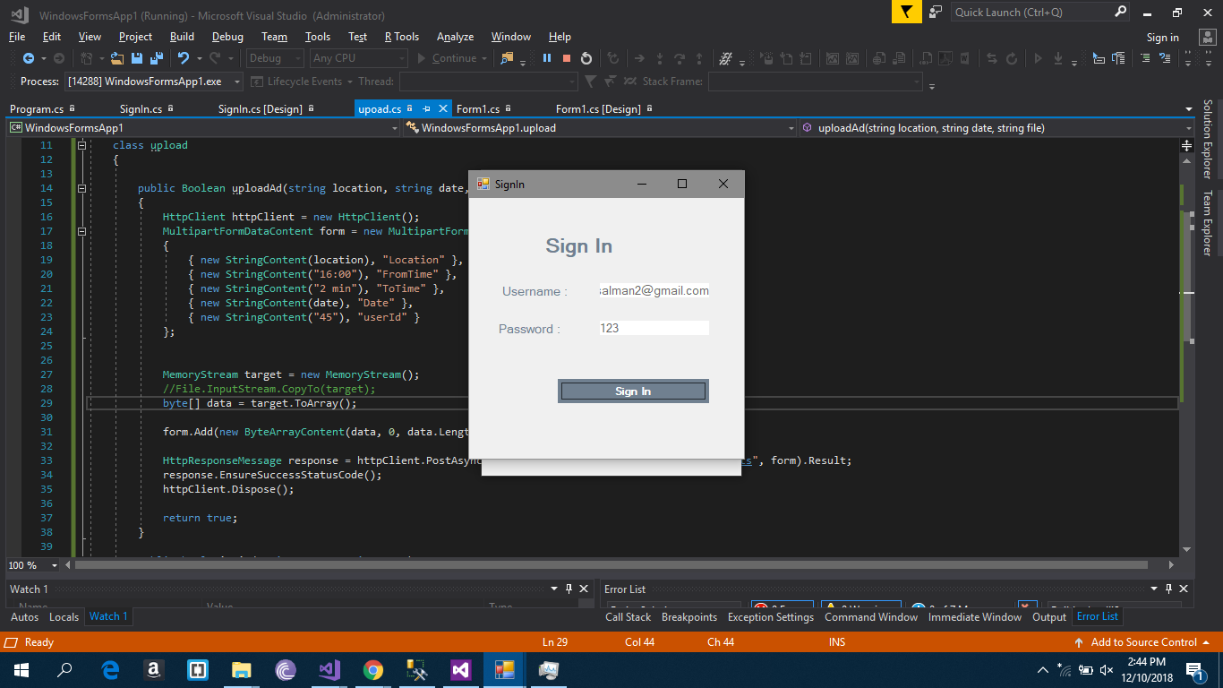 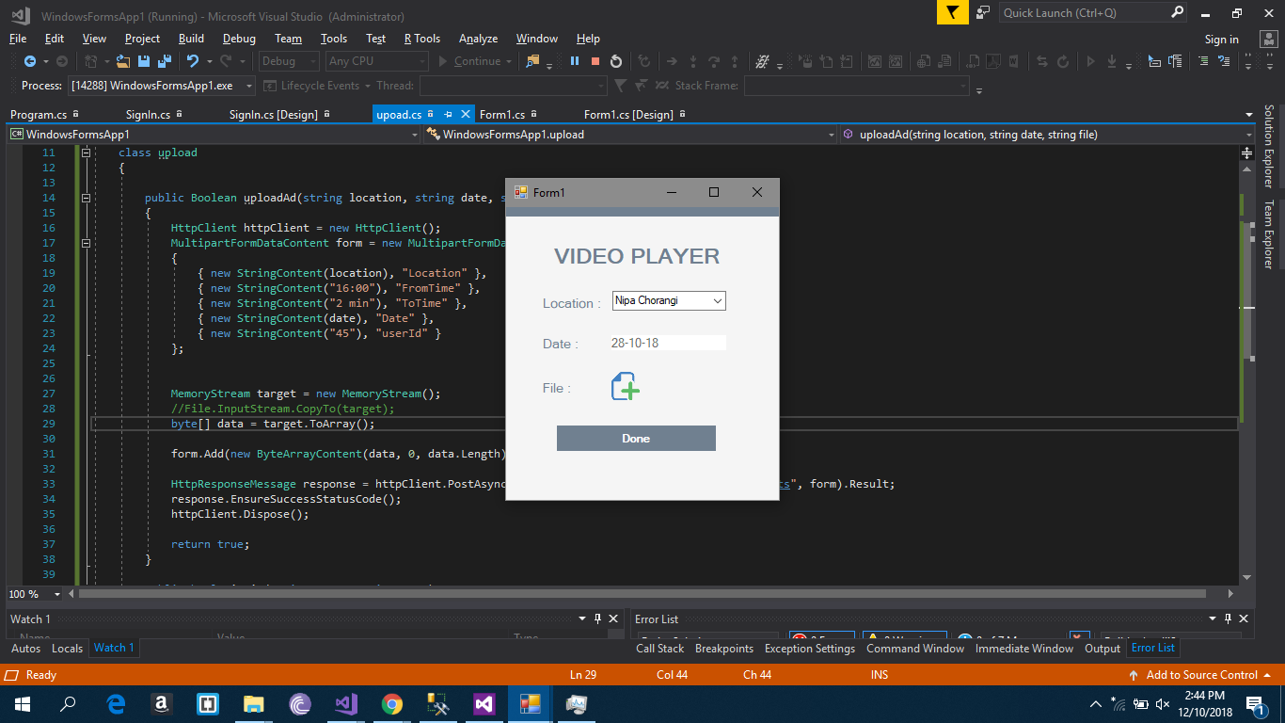

* **Client Side Design (UI):-**

On video loading

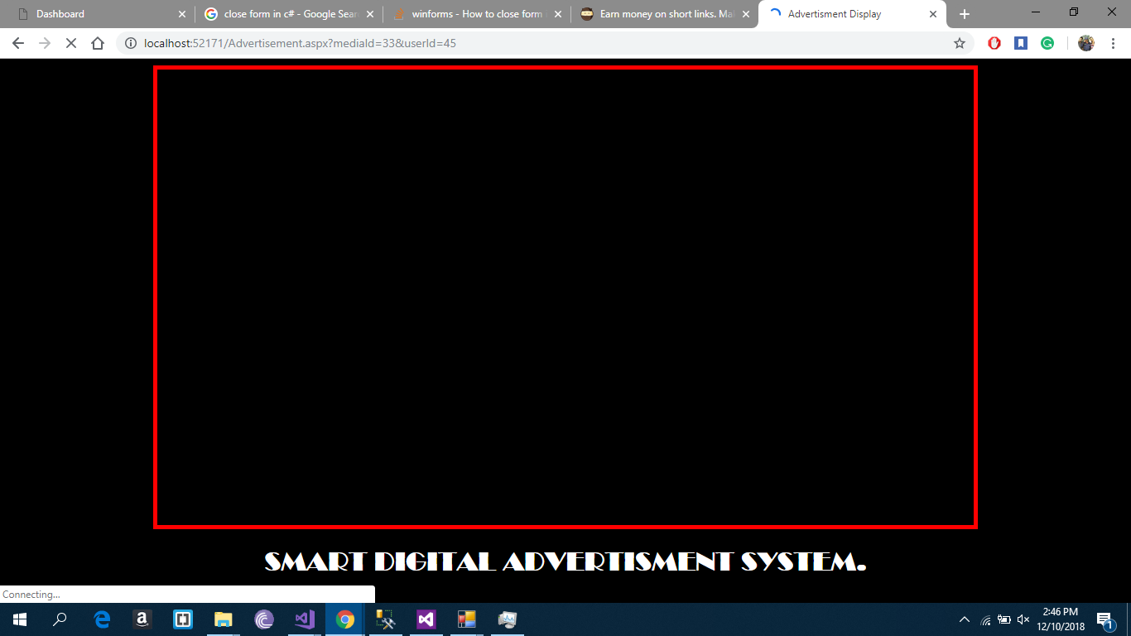

On video playing 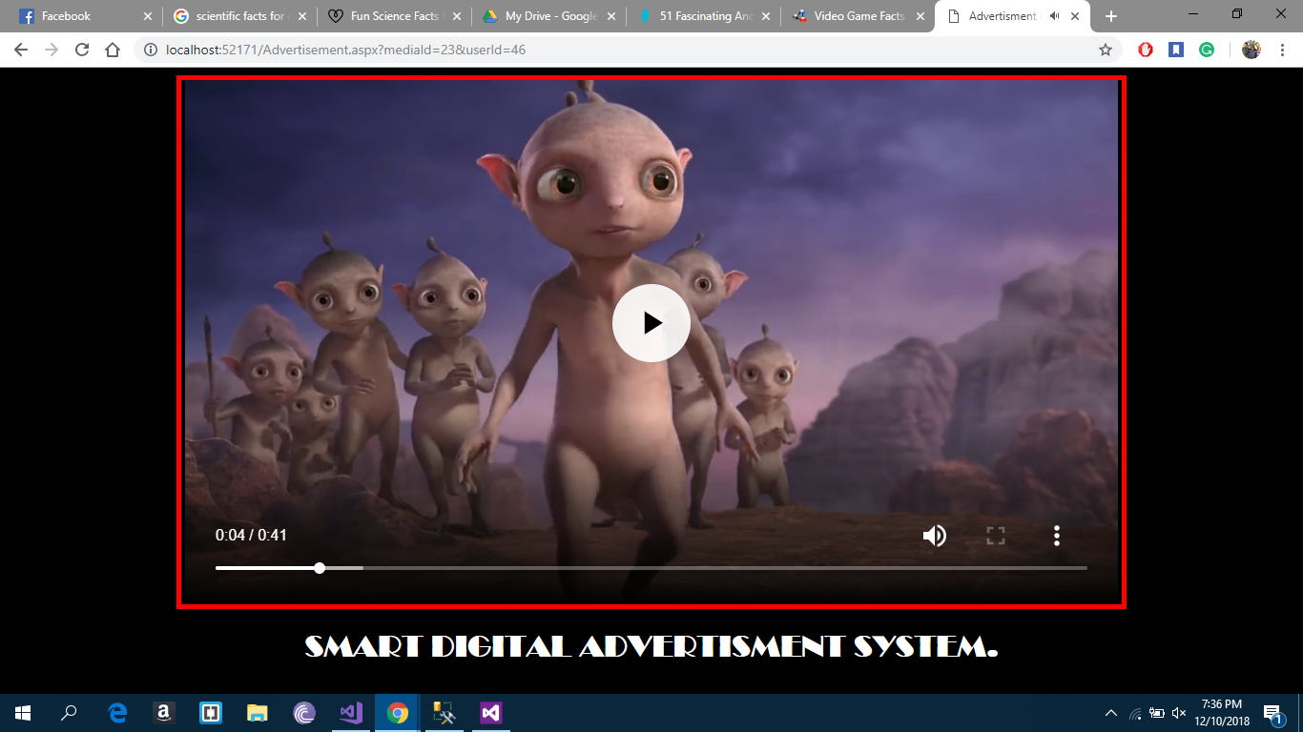

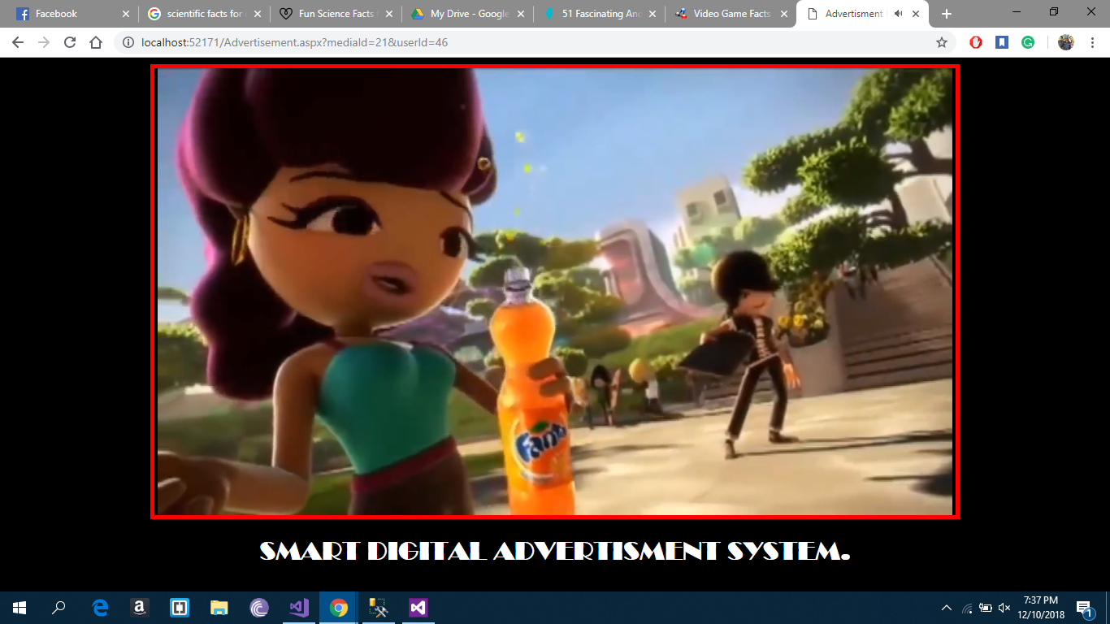

* Upload media list:

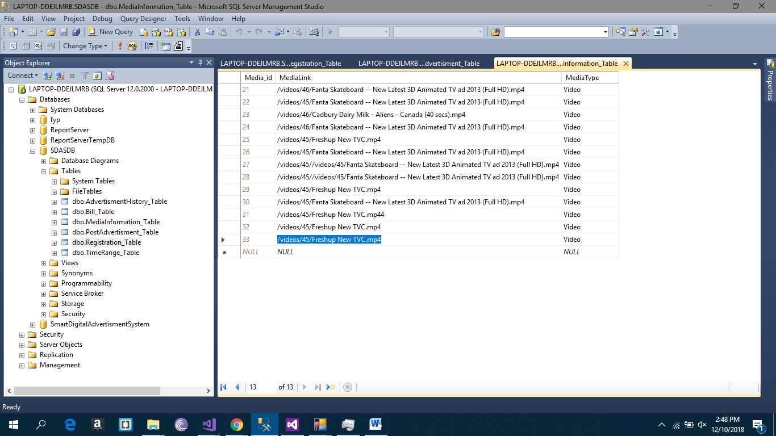

**Coding:**

In this phase we’ve started the client server communication after completion of handshaking process. Then the phase will move toward the media list uploading, downloading and opening(in case of image)/streaming(in case of audio/video)

(Socket connection for client server handshake – server end)

**API Coding:-**

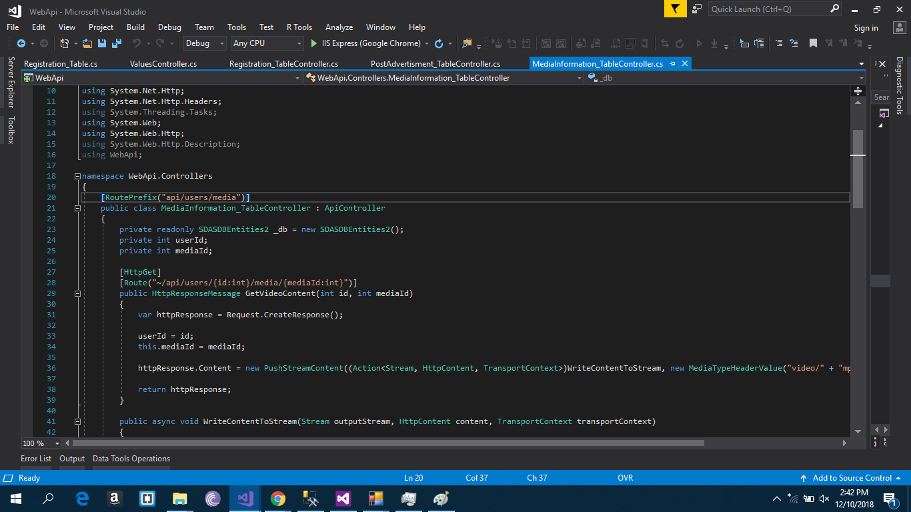

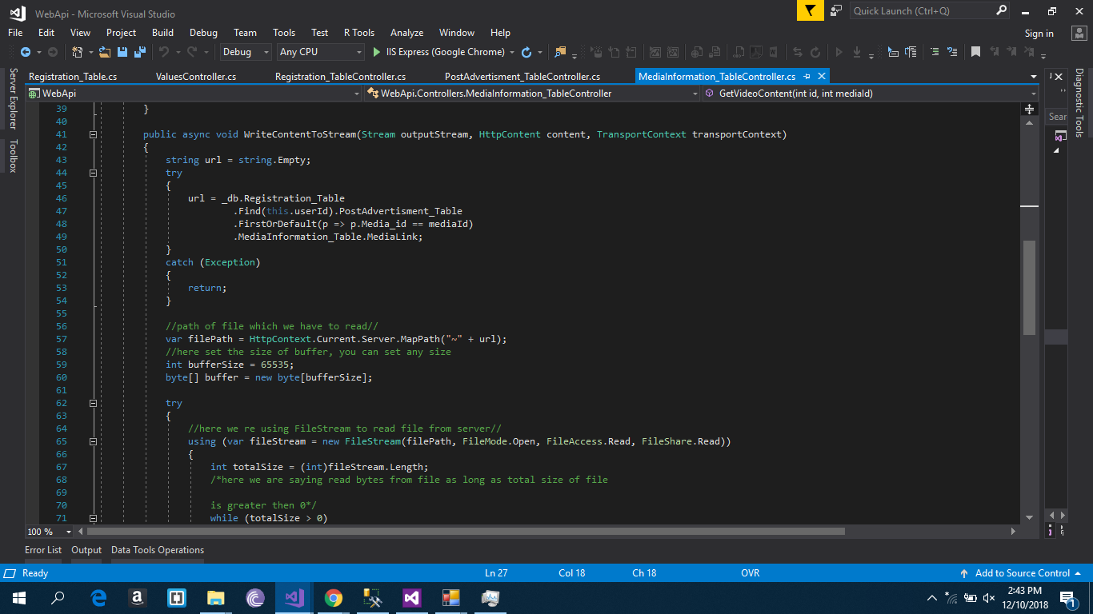

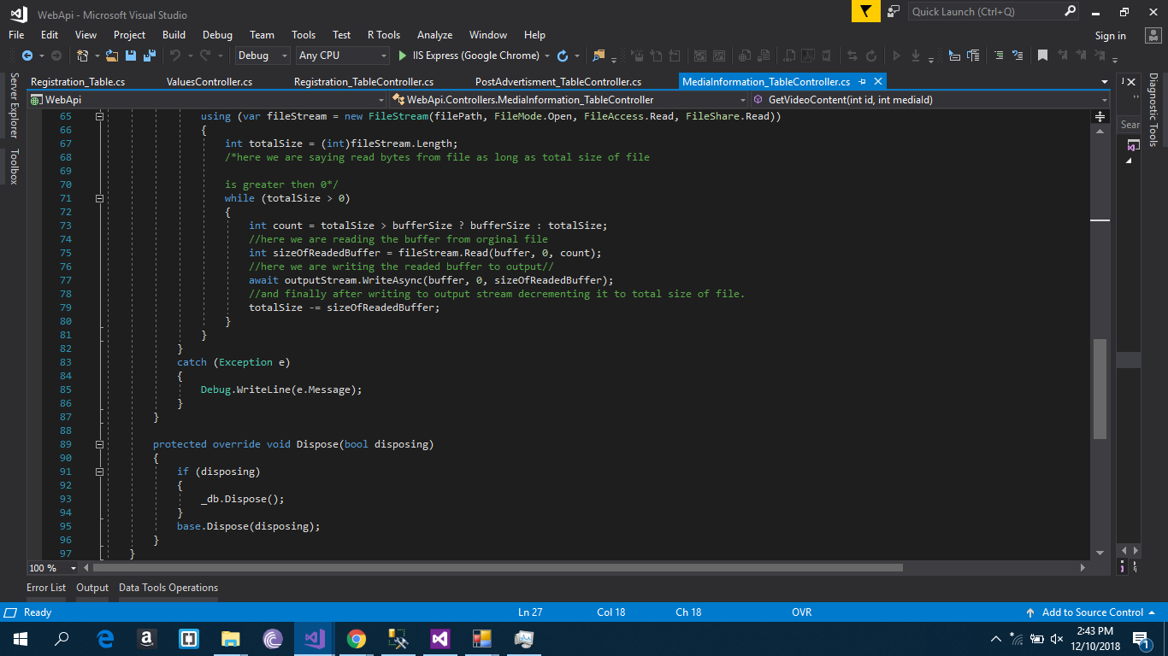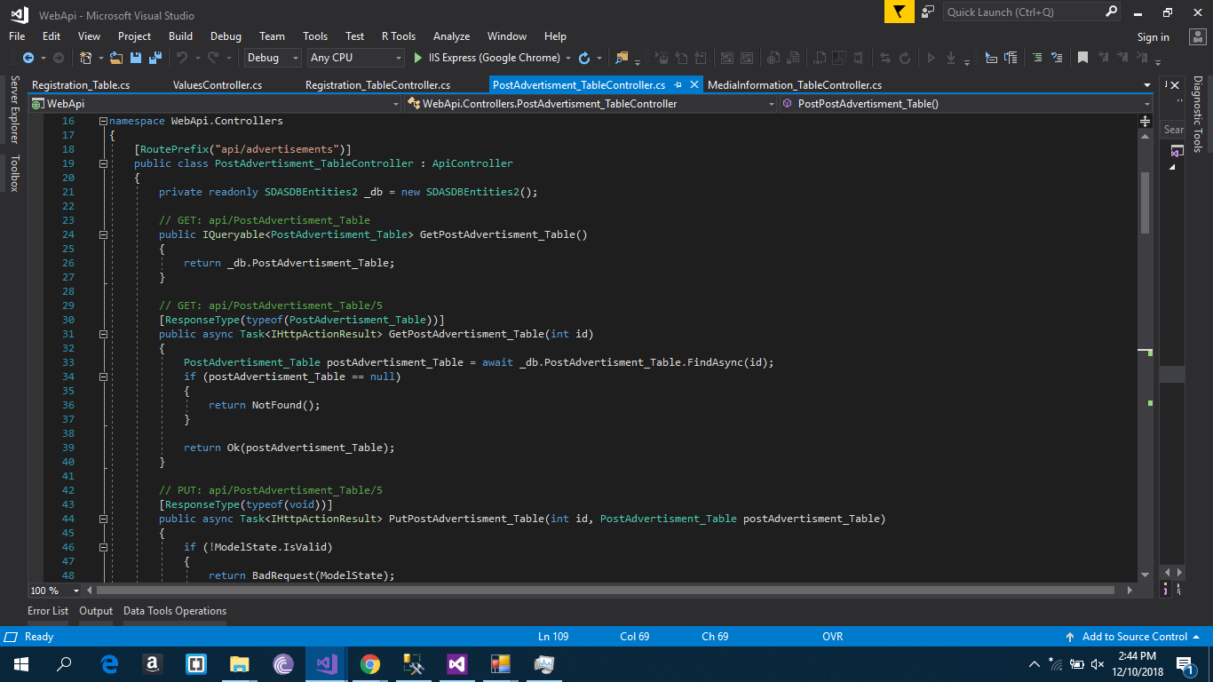

**Client Side Coding:-**

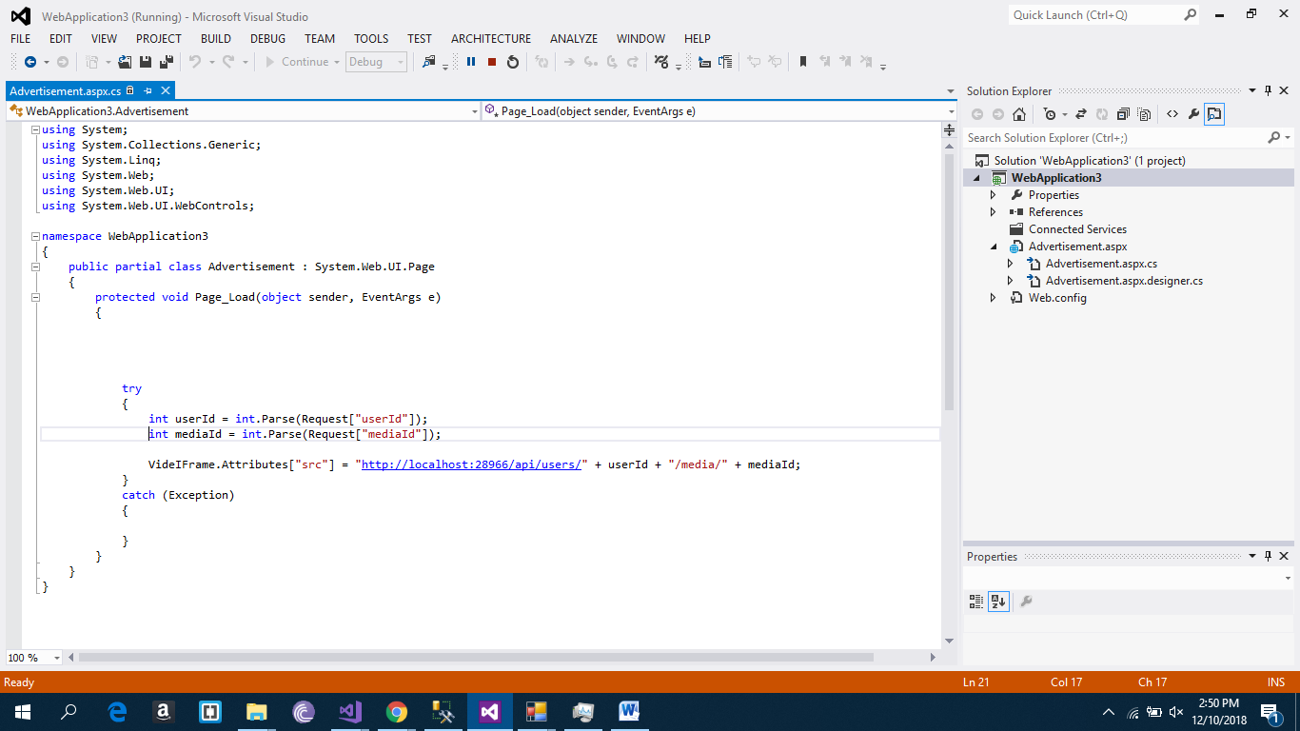



**Individual Contribution:**

Syed Hamza Ali and Arqum Usman:

Requirements gathering & analysis

Usman Tariq:

Designing of Client and Server Side User Interface

Jawwad Uddin Khan:

Coding of API, Coding of Server Side, Coding Of Client Side **and** Design of Database